The International Society of Disease Surveillance (ISDS) is committed to improving population health by advancing the science and practice of disease surveillance. One way it does this is through the R group for Biosurveillance (RGBS). This group's goal is to engage new and inexperienced users to gain skills required for data management, analysis, and visualization through the R language.



R is a free, open source, and popular statistical programming language. Because the language is powerful, yet free I suspect more and more health departments, epidemiologists, and data scientists in general will migrate to R (or Python). A recent analysis conducted by Bob Muenchen from r4stats.com indicates that R is now used for scholarly articles more frequently than all statistical languages except SPSS.

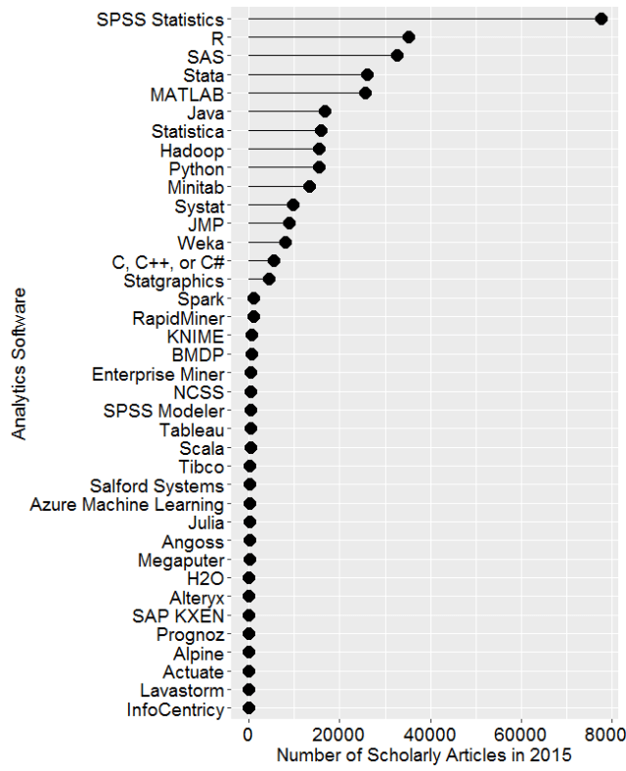

To support epidemiologists exploring R as a tool to improve public health, RGBS holds monthly webinars. These webinars facilitate the sharing of programming techniques (and code!) among current R users. The generally focus on beginners, but some advanced topics are presented as a way to give viewers an idea of what is possible with R in the hands of an expert. Webinar topics range from introducing a single package (‘surveillance’, ‘dplyr’, ‘RShiny’) to current research that used R for the analysis. Most webinars have an open-forum concept; attendees are encouraged to create a dialogue with the presenter.

In addition to the monthly webinars, we have a google discussion forum. The forum allows for new R users to plug into an existing network of peers who can provide assistance or feedback on any problem. The forum also has links to each of the previous webinar materials, including a recording, slides, and code.

Finally, ISDS is committing 2 of the pre-conference workshops of the annual conference [link: http://www.syndromic.org/annual-conference/2016-isds-conference] towards improving R capacity for public health practitioners. The **Introduction to R for Biosurveillance**will provide hands-on training for epidemiology, Biosurveillance, and high-quality data visualizations. The course will be led by Dr. Jared Niemi at Iowa State University. **Intermediate R: Practical Tools for the R User**, which I will lead, will introduce R users to several packages from the “Hadleyverse”, including dplyr, ggplot2, and tidyr. Each participant will be put into a group, given a dataset and will be able to work on a project as a team.

If you are interested in joining the R group, you can sign up here [link: <http://www.syndromic.org/cop/r>]. If you have any additional questions, or if you are interested in presenting at a webinar please don’t hesitate to contact me at [Eric.Bakota@gmail.com](mailto:Eric.Bakota@gmail.com)